A Simple Manual for Barcode Scanning System

Login

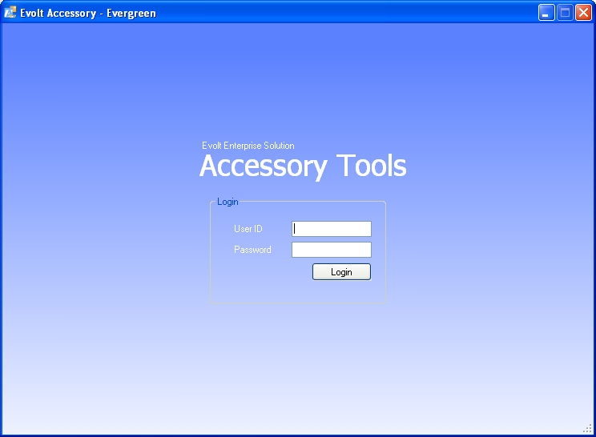

1) Please login with the same user ID and password for the backend system.

Workbench

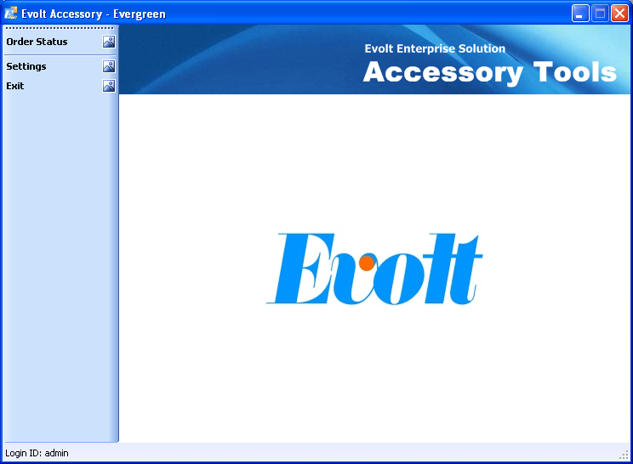

- The status bar shows the current login, it is the user ID being recorded when you scan the documents.
- Click Order Status to start the scanning process.
- If you are login as admin, the Settings button is enabled to make some configuration for the program.

Program Settings

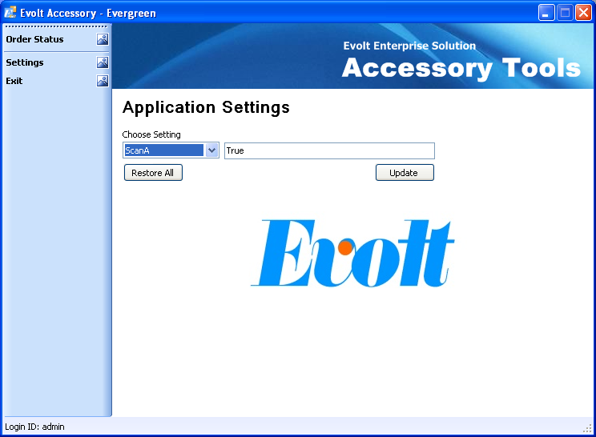

- Normally you do not need to change the service address, as it is fixed all the time. You may not be able to the use the program any more if it is set to some incorrect value.
- For the setting of ScanA ~ ScanE, you may set the value to True or False:
  - True: function is enabled.
  - False: function is disabled.
This is useful if you want to limit the functionality of certain scanning station.

Scanning Task List

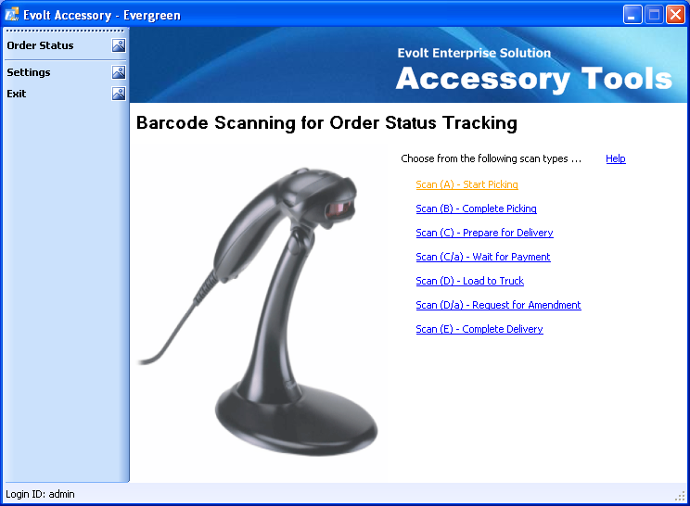

Each link is enabled if it is set to True in the settings.

Scanning Panel

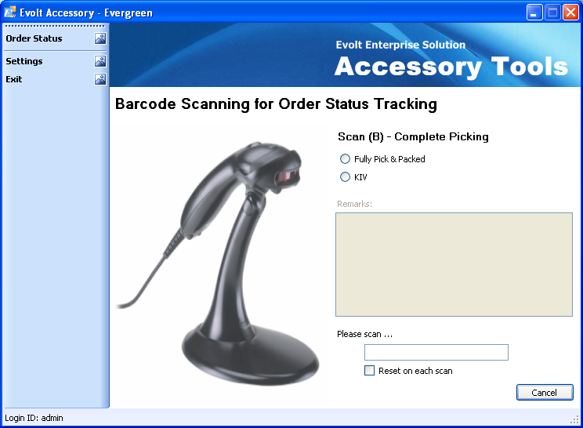

- If the Reset on each scan is checked, all the options remain after each successful scanning.
- Please make sure the text below Please scan … is on focus before each scanning. The USB scanner simulates keyboard input; the text box must be focused to receive the barcode inputs.
- In case some barcodes are not in good condition to be scanned, you may key in the value manually using keyboard and press Enter at the end of inputs.
- The barcode is usually a sequence of 17 digits, for example 10001101001033862
- Click cancel to return to the Scanning Task List.

System Query

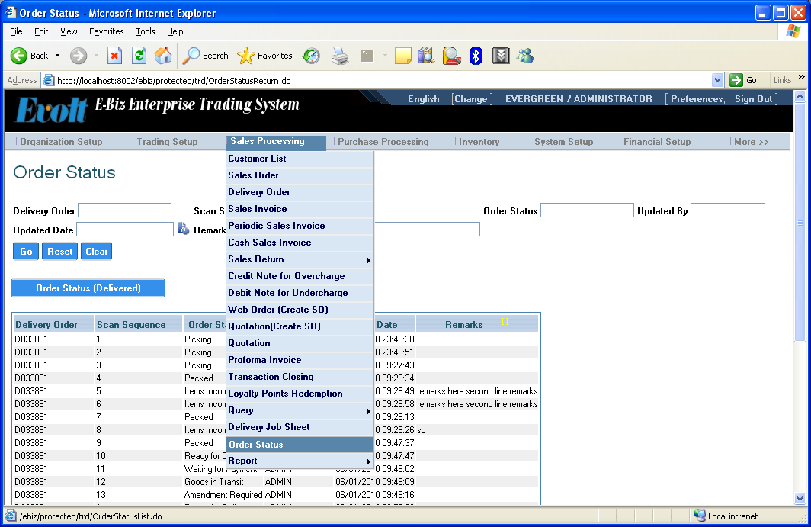

- A new menu Order Status is added under Sales Processing.
- Scan Sequence indicates the order of scanning. The largest number means the latest scan.

Online Order Status

Without login

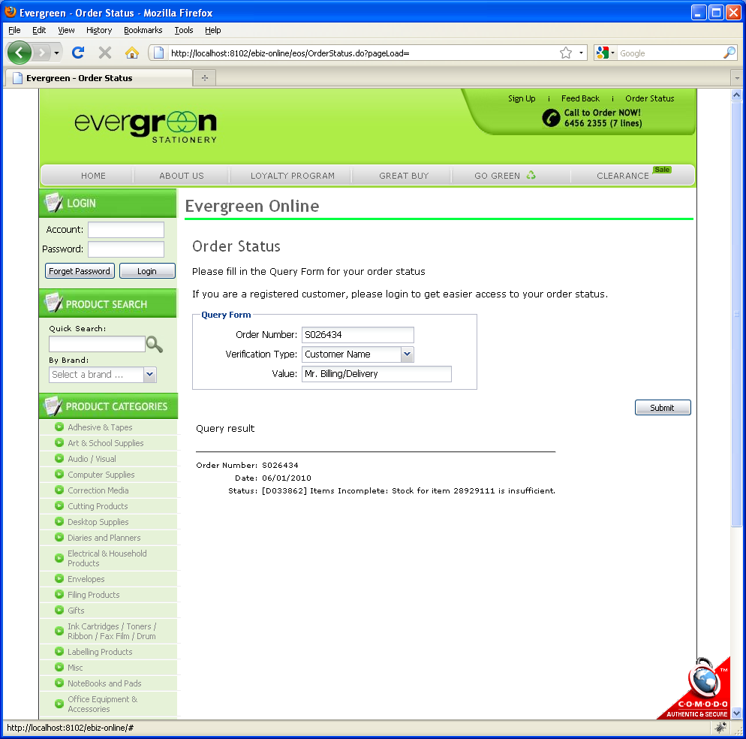

After login



